**Poker game**

**(Product Backlog)**

**https://github.com/srhee91/PokerGame**

Team 3

So Mi Choi, Bo Heon Jeong, Hanchen Li, Sang Rhee, Yixin Wang, Yuying Wang

**Product Backlog**

Problem Statement:

People need to have fun gambling without losing actual money online. An interactive Texas Hold’em game can be created to satisfy this need.

Background:

Most poker games that exist currently are played over the web between total strangers. We aim to offer a casual poker game that you and your friends can play on their laptops/desktops connected over a local network. New users can jump right in without providing credentials or real money. Our targeted users are those who want to enjoy a game of poker together, but don’t have physical playing cards or chips. While there are a lot of existing poker applications out there (such as Zynga Poker), most are focused on playing with strangers far away. Our game hopes to make a “LAN party” atmosphere possible for poker. A slight variation on our proposed solution would be a poker game running on a single system being shared by all players (in other words, passing a laptop around), but we believe having 8 players share one system is too inconvenient.

System model:

1. Diagram

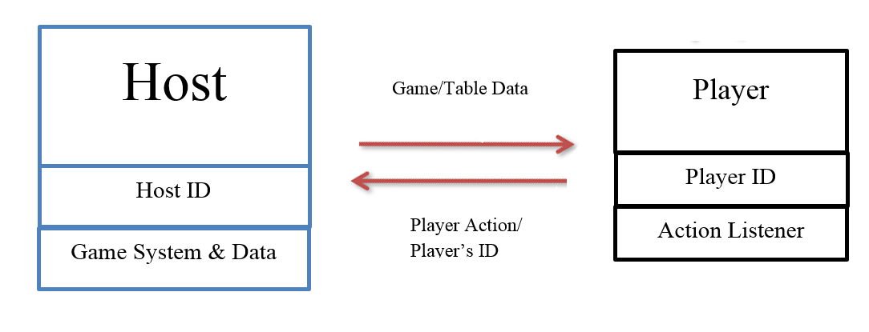

1. Interactions
   1. When the game is being played
      1. Host sends “game data” to Player
      2. Player sends “player action” to Host
   2. Before the game is started
      1. Player sends “Player’s ID” to Host
      2. Host sends “table info” to Player

Requirements:

* Must be done
* Functional
  + As a user, I would like four modes for this program: “startup”, “lobby”, “ongoing”, and “over”.
    - As a user in the “startup” state, I would like the options of creating (hosting) a game or joining an existing game lobby. I would like to choose the desired game by specifying a port number.
    - As a player (not host) in the “lobby” state, I would like to see onscreen the names of all the players that have joined in real-time. As a host in the “lobby” state, I would like to be presented the option of starting the game as soon as there are at least two players in the game.
    - As a player in the “ongoing” state, I would like to see all the players’ names, chip amounts, and cards (face up or down depending on the situation) as well as onscreen buttons that allow me to choose an action (fold, check/call, raise/all in) when it’s my turn.
    - As a player in the “over” state, I would like to be shown onscreen the name of the winner, relevant game stats, and a button that will take me back to the “startup” state when I’m finished viewing the info.
  + As a user, I would like to be able to join an existing game lobby that I specify by port number and for the system to display an onscreen error message if I try to join a game that has already started or is nonexistent.
  + As a player in an ongoing game, I would like to be able to quit said game through an onscreen button and return to the “startup” screen.
  + As a player in an ongoing game, I would like my game screen to be updated in real time anytime an action occurs in the game (e.g. a player folds, the dealer changes, the flop being revealed, etc.).
  + As a player, I would like a time limit of 30 seconds per turn imposed on all players before forcing them to fold to limit the amount of time players have to wait between turns. I would like the time remaining to be displayed onscreen during my turn.
  + As a player in a game lobby or an ongoing game, I would like changes to the game state to be conveyed to me through intuitive onscreen animations accompanied by sounds. An example of such an action is to show cards moving across the screen when being dealt to players.
* Non-functional
  + The game will be programmed in Java. The Slick2D library will be used for rendering the game screen.
  + The game will run at a minimum 60 frames per second at all times on any system that’s at least as powerful as a modern entry-level laptop.
  + If the game state for a player gets out of sync with what the host has stored, it will be corrected for that player the next time the game state changes (assuming the error responsible was temporary and did not permanently disconnect that player from the host).
  + If a player’s system crashes for some reason, the game host will detect this and remove that player from the game, as if he/she had willingly quit.
  + If a host’s system crashes for some reason, a game in the “lobby” or “ongoing” state will immediately revert back to the “startup” state for all other players, gracefully ending the game.
  + Any onscreen buttons that represents a definite invalid action in the game’s current state will be grayed out to convey this to the user.
* Will be done if time allows
* Functional
  + As a user trying to join a game lobby, I would like to be able to choose among all existing game lobbies through an onscreen scrollable list instead of specifying a game’s port number.
  + As a user in a game lobby or an ongoing game, I would like an onscreen chat box that allows players to send typed messages that will be visible to all players.
* Non-functional
  + Players will be reconnected to the host immediately if their connection to the host is temporarily lost.
  + Host migration: if the host leaves a game in the “lobby” or “ongoing” state, another player will automatically be chosen to become the new host, and the game will continue from its last game state.